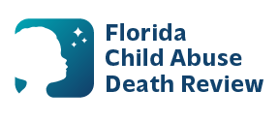
AGENDA
Circuit 13
Local Child Abuse Death Review Meeting
July 8, 2026
1:00 pm - 1:15 pm
Teams Meeting:
Meeting ID: 210 705 414 830 997
Passcode: QG9xv3UP

- Welcome and Introductions
- Local CADR Business
- CADR Program Updates
- Other Business
- Adjourn

