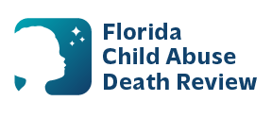
AGENDA
Circuit 14
Local Child Abuse Death Review Meeting
July 14, 2026
August 11, 2026
September 8, 2026
October 13, 2026
November 10, 2026
December 8, 2026

Time: 9:45 am - 10:00 am

Teams Meeting:
Meeting ID: 219 767 651 990 262
Passcode: vL2Vo23S

- Welcome and Introductions
- Local CADR Business
- CADR Program Updates
- Other Business
- Adjourn

