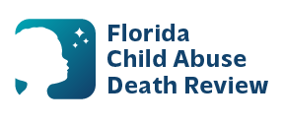
AGENDA
Circuit 8 Local Child Abuse Death Review Meeting
Meeting Date: Jun 23, 2026
Time: 1:00 PM- 1:15 PM
Meeting Place: Zoom
Meeting ID: 777 2560 5449
Passcode: 5avaP5

- Welcome and Introductions
- Local CADR Business
- CADR Program Updates
- Other Business
- Adjourn

