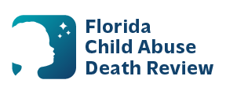
AGENDA
Circuit 9 Local Child Abuse Death Review Meeting
Meeting Date: June 26, 2026
Time: 1:00 PM – 1:30 PM
Microsoft Teams:
Meeting ID: 275 861 804 155 799
Passcode: ss9LH27N

- Welcome and Introductions
- Local CADR Business
- CADR Program Updates
- Other Business
- Adjourn

