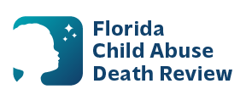
sherry.duncan@flhealth.gov AGENDA
Circuit 7 Local Child Abuse Death Review Meeting
Meeting Date: June 9, 2026
Time: 1:30 PM - 1:45 PM
PLACE: St Johns County Health Department
Muscovy Conference Room
1st floor
200 San Sebastian View
St Augustine, Florida 32084

- Welcome and Introductions
- Local CADR Business
- CADR Program Updates
- Other Business
- Adjourn

