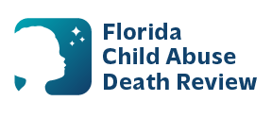
AGENDA
Circuit 7 Local Child Abuse Death Review Meeting
Meeting Date: June 23, 2026
Time: 2:00 pm – 2:15 pm
Meeting Place:
Microsoft Teams:
Meeting ID: 290 875 275 342 970
Passcode: aW9oA9Tz

- Welcome and Introductions
- Local CADR Business
- CADR Program Updates
- Other Business
- Adjourn

