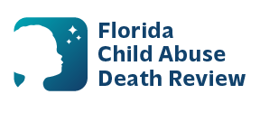
AGENDA
Local Child Abuse Death Review Meeting
Circuit 13
August 12, 2026
1:00 pm - 1:15 pm
Microsoft Teams Meeting:
Meeting ID: 244 611 401 271 629
Passcode: UK6Ju6rP

- Welcome and Introductions
- Local CADR Business
- CADR Program Updates
- Other Business
- Adjourn

