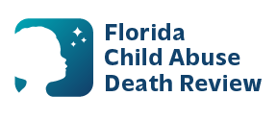
AGENDA
Local Child Abuse Death Review Meeting
Circuit 13
September 9, 2026
1:00 pm - 1:15 pm
Microsoft Teams Meeting:
Meeting ID: 278 604 054 163 436
Passcode: 3KX9Du2v

- Welcome and Introductions
- Local CADR Business
- CADR Program Updates
- Other Business
- Adjourn

