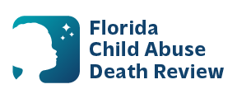
AGENDA
Circuit 7 Local Child Abuse Death Review Meeting
Flagler
Meeting Dates:
August 10, 2026
PLACE:
Microsoft Teams:
Meeting ID: 219 848 797 787 370
Passcode: JG2Qq2yk

- Welcome and Introductions
- Local CADR Business
- CADR Program Updates
- Other Business
- Adjourn

