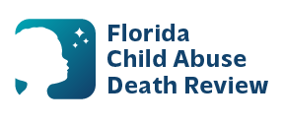
sherry.duncan@flhealth.gov AGENDA
Circuit 7 Local Child Abuse Death Review Meeting
Putnam
Meeting Date: August 18, 2026
Time: 1:30 PM – 2:30 PM
PLACE:
Microsoft Teams:
Meeting ID: 277 807 585 261 380
Passcode: LB6Av26z

- Welcome and Introductions
- Local CADR Business
- CADR Program Updates
- Action Plan Discuss
- Other Business
- Adjourn

