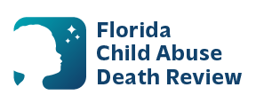
sherry.duncan@flhealth.gov AGENDA
Circuit 7 Local Child Abuse Death Review Meeting
Volusia
Meeting Dates:
August 25, 2026
September 22, 2026
October 27, 2026
November 24, 2026
Time: 2:00pm - 2:15 pm
PLACE:
Microsoft Teams:
Meeting ID: 248 144 942 824 980
Passcode: X7PW6ss3

- Welcome and Introductions
- Local CADR Business
- CADR Program Updates
- Other Business
- Adjourn

